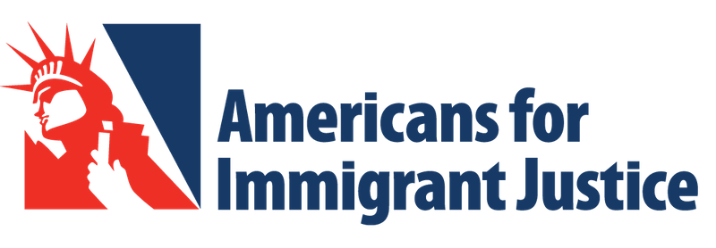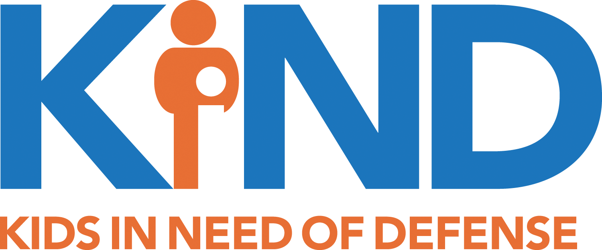

FOR IMMEDIATE RELEASE
April 7, 2022
CONTACT
Florence Immigrant & Refugee Rights Project
Greer Millard
media@firrp.org; (602) 795-7407

Immigration Advocates File Complaints Protesting the Treatment of Children in Customs and Border Protection (CBP) Custody
Yesterday, four immigration advocacy organizations across the country filed complaints with the Office of Civil Rights and Civil Liberties (CRCL) and the Office of the Inspector General (OIG) detailing patterns of abuse and mistreatment of immigrant children in CBP custody at the southern border. The four organizations – Kids in Need of Defense (KIND), Americans for Immigrant Justice (AI Justice), Florence Immigrant & Refugee Rights Project (FIRRP), and Immigrant Defenders Law Center (ImmDef) – represent unaccompanied noncitizen children across the country, from California to New York and Florida to Seattle.
Our organizations serve children all over the country, yet the children we serve all report similar experiences in CBP custody. For instance, AI Justice reports that 70% of the children they interviewed reported experiencing conditions or abuse while in CBP custody that violated the Flores Agreement. Similarly, the Florence Project has filed more than 130 CRCL complaints on behalf of children who, between January and August 2021, suffered mistreatment including excessive detention, verbal and physical abuse, deprivation of medical care, insufficient food and water, family separation, and other human rights violations.

“What we’re really seeing is the same trends of mistreatment and abuse that we’ve seen for years,” says Laura Belous, Advocacy Attorney at the Florence Immigrant & Refugee Rights Project. “In our complaints, we are calling on CBP to follow existing law and policy, particularly the Flores Settlement Agreement and CBP’s own standards on Transport, Escort, Detention and Search (TEDS).”
“This administration, like others before it, has fallen short on protecting the rights of children in CBP custody,” says Maite Garcia, Senior Attorney at Americans for Immigrant Justice. “It is long overdue that our government live up to the promises in the Flores settlement agreement and the TVPRA and implement a system that is guided by the best interest of the children in their custody.”

“ImmDef has long been alarmed and disappointed by CBP's mistreatment of unaccompanied children in its custody,” says Carson Scott, Staff attorney at Immigrant Defenders Law Center. “We file these complaints to hold CBP accountable for its gross violations of well-established legal rules and to urge the agency to participate in stakeholder-led discussions to reimagine the agency's approach to the vulnerable children in its custody.”
“We call on the DHS Office for Civil Rights and Civil Liberties and the Office of the Inspector General to investigate these widespread reports of abuses of unaccompanied children detained by CBP,” says KIND President Wendy Young. “The treatment of these children is abhorrent and in violation of law, policy, and the notion of humane reception at our nation’s borders. The abuse underscores the need for DHS to honor Congress’ directive as part of the 2022 Consolidated Appropriations Act to hire state-licensed child welfare professionals at southern land border CBP facilities. Unlike CBP agents and officers, these professionals have the expertise to conduct protection screenings of arriving children and ensure appropriate care.”

“Children who seek protection at our border spend their first, critical days in the custody of U.S. Customs and Border Protection (CBP),” says Jane Liu, Senior Litigation Attorney at the Young Center for Immigrant Children Rights, which supported and consulted on this effort. “At a minimum, CBP must comply with existing laws, provide safe spaces for all children, and treat all children with dignity and respect. But the complaints filed today demonstrate the agency’s failure to meet even the most basic standards of adequate food, hygiene, beds, and medical attention. The Office of Civils Rights and Civil Liberties has both an obligation to investigate and an opportunity to shine a light on the many aspects of CBP custody that remain hidden from public view.”

Together, KIND, AI Justice, the Florence Project, the Young Center, and ImmDef call on CBP to find a trauma-informed and child-friendly system to welcome, screen, and ensure the safety of children arriving to the United States seeking protection.

